**[PL SQL programming](https://github.com/seshadrimr/Digital-Nurture-4.0-JavaFSE/tree/main/Java%20FSE/Deepskilling/PL%20SQL%20programming)**

**Setting Up Schema :**

CREATE TABLE Customers (

CustomerID NUMBER PRIMARY KEY,

Name VARCHAR2(100),

DOB DATE,

Balance NUMBER,

LastModified DATE

);

CREATE TABLE Accounts (

AccountID NUMBER PRIMARY KEY,

CustomerID NUMBER,

AccountType VARCHAR2(20),

Balance NUMBER,

LastModified DATE,

FOREIGN KEY (CustomerID) REFERENCES Customers(CustomerID)

);

CREATE TABLE Transactions (

TransactionID NUMBER PRIMARY KEY,

AccountID NUMBER,

TransactionDate DATE,

Amount NUMBER,

TransactionType VARCHAR2(10),

FOREIGN KEY (AccountID) REFERENCES Accounts(AccountID)

);

CREATE TABLE Loans (

LoanID NUMBER PRIMARY KEY,

CustomerID NUMBER,

LoanAmount NUMBER,

InterestRate NUMBER,

StartDate DATE,

EndDate DATE,

FOREIGN KEY (CustomerID) REFERENCES Customers(CustomerID)

);

CREATE TABLE Employees (

EmployeeID NUMBER PRIMARY KEY,

Name VARCHAR2(100),

Position VARCHAR2(50),

Salary NUMBER,

Department VARCHAR2(50),

HireDate DATE

);

**Inserting Values in the SCHEMA**

INSERT INTO Customers (CustomerID, Name, DOB, Balance, LastModified)

VALUES (1, 'John Doe', TO_DATE('1985-05-15', 'YYYY-MM-DD'), 1000, SYSDATE);

INSERT INTO Customers (CustomerID, Name, DOB, Balance, LastModified)

VALUES (2, 'Jane Smith', TO_DATE('1990-07-20', 'YYYY-MM-DD'), 1500, SYSDATE);

**Output**

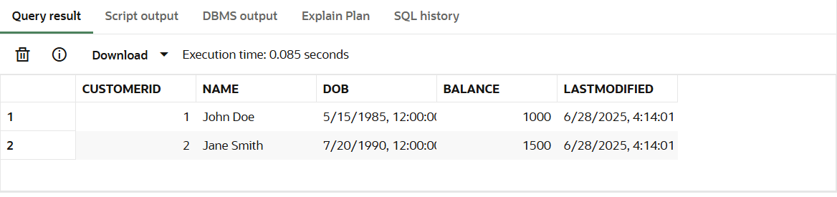

INSERT INTO Accounts (AccountID, CustomerID, AccountType, Balance, LastModified)

VALUES (1, 1, 'Savings', 1000, SYSDATE);

INSERT INTO Accounts (AccountID, CustomerID, AccountType, Balance, LastModified)

VALUES (2, 2, 'Checking', 1500, SYSDATE);

**Output**

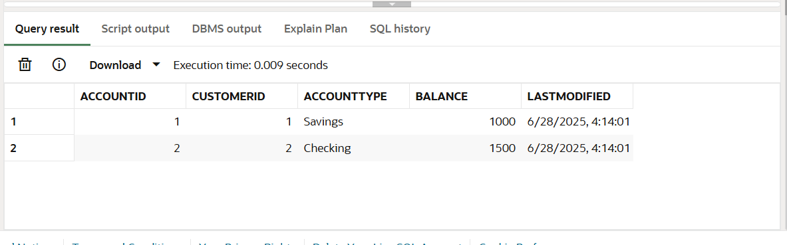

INSERT INTO Transactions (TransactionID, AccountID, TransactionDate, Amount, TransactionType)

VALUES (1, 1, SYSDATE, 200, 'Deposit');

INSERT INTO Transactions (TransactionID, AccountID, TransactionDate, Amount, TransactionType)

VALUES (2, 2, SYSDATE, 300, 'Withdrawal');

**Output**

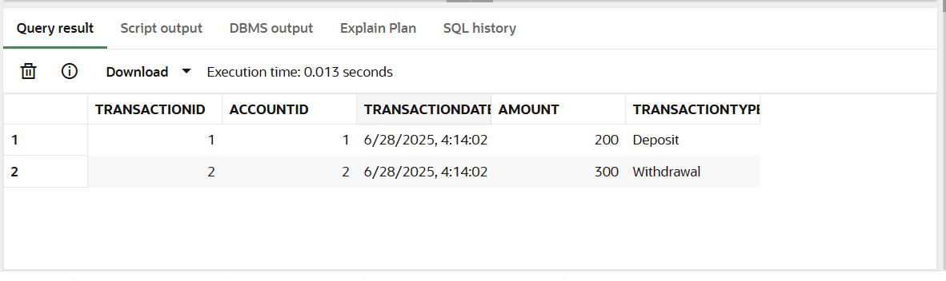

INSERT INTO Loans (LoanID, CustomerID, LoanAmount, InterestRate, StartDate, EndDate)

VALUES (1, 1, 5000, 5, SYSDATE, ADD_MONTHS(SYSDATE, 60));

INSERT INTO Loans (LoanID, CustomerID, LoanAmount, InterestRate, StartDate, EndDate)

VALUES (2, 2, 10000, 6, SYSDATE, SYSDATE + 10);

**Output**

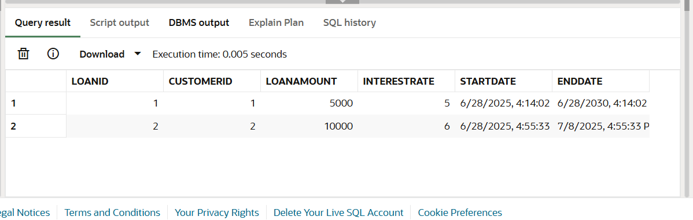

INSERT INTO Employees (EmployeeID, Name, Position, Salary, Department, HireDate)

VALUES (1, 'Alice Johnson', 'Manager', 70000, 'HR', TO_DATE('2015-06-15', 'YYYY-MM-DD'));

INSERT INTO Employees (EmployeeID, Name, Position, Salary, Department, HireDate)

VALUES (2, 'Bob Brown', 'Developer', 60000, 'IT', TO_DATE('2017-03-20', 'YYYY-MM-DD'));

**Output**

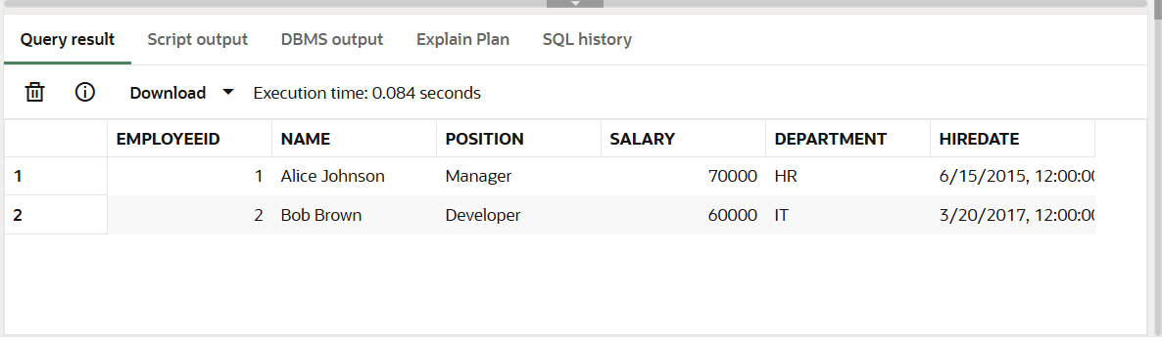

**Question 1:**

**Scenario 1:**

BEGIN

FOR cust_rec IN (SELECT CustomerID, DOB FROM Customers) LOOP

IF MONTHS_BETWEEN(SYSDATE, cust_rec.DOB) / 12 > 60 THEN

UPDATE Loans

SET InterestRate = InterestRate - 1

WHERE CustomerID = cust_rec.CustomerID;

END IF;

END LOOP;

END;

/

**Scenario 2:**

ALTER TABLE Customers ADD (IsVIP VARCHAR2(5));

BEGIN

FOR cust IN (SELECT CustomerID, Balance FROM Customers) LOOP

IF cust.Balance > 10000 THEN

UPDATE Customers

SET IsVIP = 'TRUE'

WHERE CustomerID = cust.CustomerID;

ELSE

UPDATE Customers

SET IsVIP = 'FALSE'

WHERE CustomerID = cust.CustomerID;

END IF;

END LOOP;

END;

/

**Outputs:**

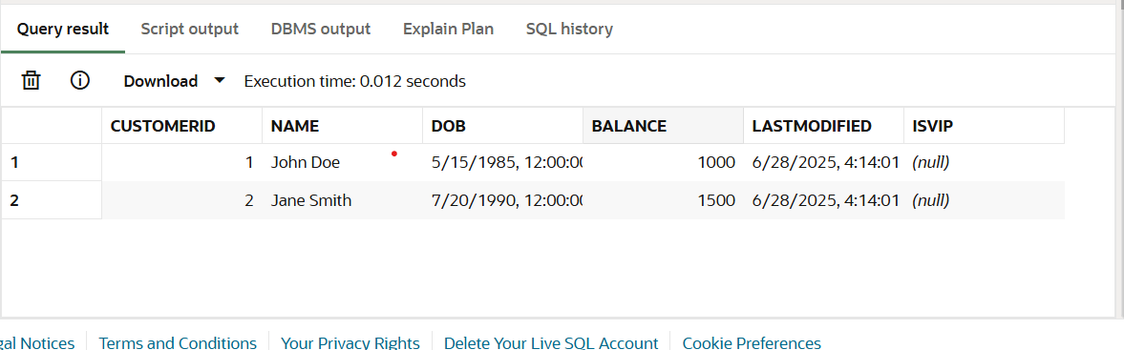

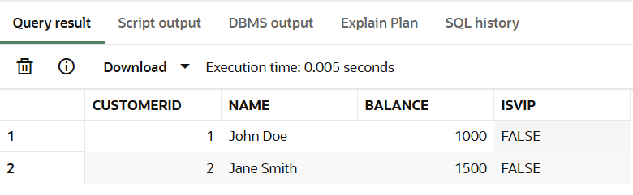

**Scenario 3:**

BEGIN

FOR loan_rec IN (

SELECT c.Name, l.LoanID, l.EndDate

FROM Loans l

JOIN Customers c ON c.CustomerID = l.CustomerID

WHERE l.EndDate BETWEEN SYSDATE AND SYSDATE + 30

) LOOP

DBMS_OUTPUT.PUT_LINE('Reminder: Loan ID ' || loan_rec.LoanID ||

' for customer ' || loan_rec.Name ||

' is due on ' || TO_CHAR(loan_rec.EndDate, 'DD-Mon-YYYY'));

END LOOP;

END;

/

**Output:**

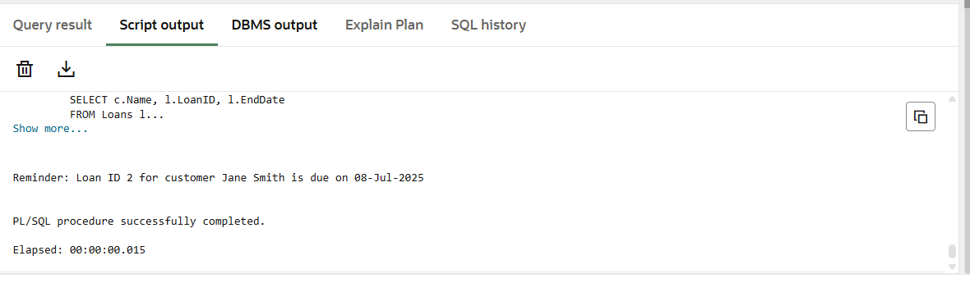

**Question 2:**

**Scenario 1:**

CREATE OR REPLACE PROCEDURE SafeTransferFunds (

from_account_id IN NUMBER,

to_account_id IN NUMBER,

amount IN NUMBER

) IS

insufficient_funds EXCEPTION;

from_balance NUMBER;

BEGIN

-- Get sender balance

SELECT Balance INTO from_balance FROM Accounts WHERE AccountID = from_account_id;

-- Check balance

IF from_balance < amount THEN

RAISE insufficient_funds;

END IF;

-- Subtract from sender

UPDATE Accounts

SET Balance = Balance - amount

WHERE AccountID = from_account_id;

-- Add to receiver

UPDATE Accounts

SET Balance = Balance + amount

WHERE AccountID = to_account_id;

DBMS_OUTPUT.PUT_LINE('✅ Transfer of $' || amount || ' successful.');

EXCEPTION

WHEN insufficient_funds THEN

DBMS_OUTPUT.PUT_LINE('❌ Transfer failed: Insufficient funds.');

ROLLBACK;

WHEN OTHERS THEN

DBMS_OUTPUT.PUT_LINE('❌ Transfer failed: ' || SQLERRM);

ROLLBACK;

END;

/

**Test Query:**

BEGIN

SafeTransferFunds(1, 2, 300);

END;

/

**Output**

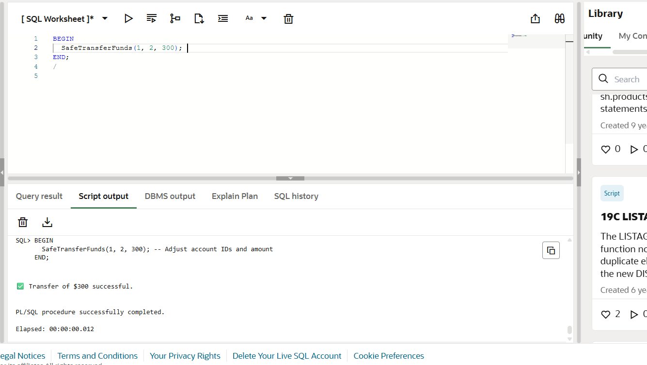

**Scenario 2:**

CREATE OR REPLACE PROCEDURE UpdateSalary (

emp_id IN NUMBER,

percentage IN NUMBER

) IS

emp_not_found EXCEPTION;

emp_salary Employees.Salary%TYPE;

BEGIN

-- Check if employee exists

SELECT Salary INTO emp_salary FROM Employees WHERE EmployeeID = emp_id;

-- Update salary

UPDATE Employees

SET Salary = Salary + (Salary * percentage / 100)

WHERE EmployeeID = emp_id;

DBMS_OUTPUT.PUT_LINE('✅ Salary updated by ' || percentage || '% for Employee ID ' || emp_id);

EXCEPTION

WHEN NO_DATA_FOUND THEN

DBMS_OUTPUT.PUT_LINE('❌ Error: Employee ID ' || emp_id || ' does not exist.');

WHEN OTHERS THEN

DBMS_OUTPUT.PUT_LINE('❌ Error: ' || SQLERRM);

END;

/

**Test Query:**

BEGIN

UpdateSalary(1, 10);

END;

/

**Outputs**

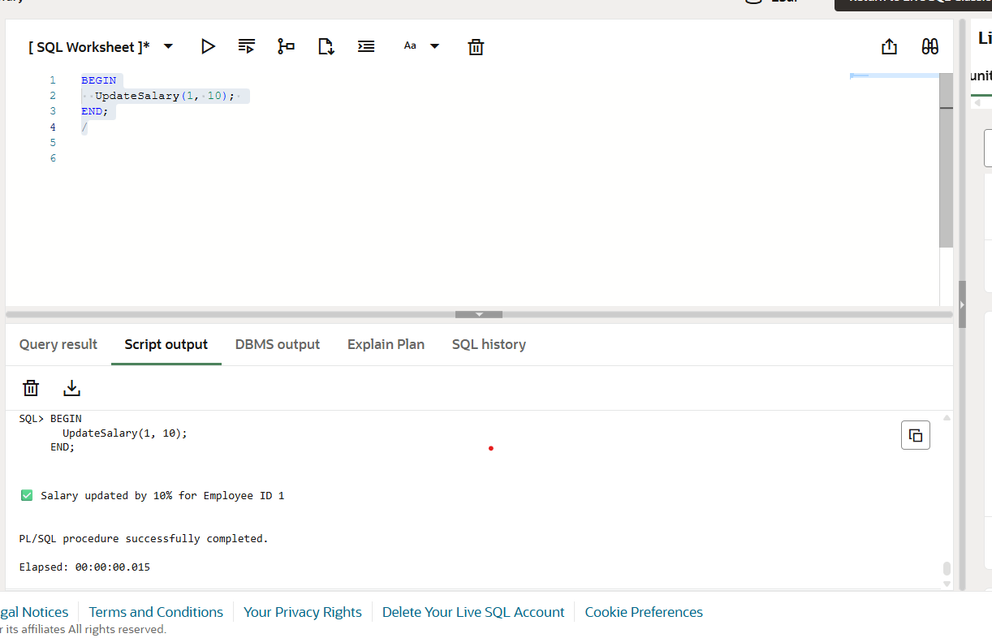

**Scenario 3:**

CREATE OR REPLACE PROCEDURE AddNewCustomer (

p_id IN NUMBER,

p_name IN VARCHAR2,

p_dob IN DATE,

p_balance IN NUMBER

) IS

BEGIN

INSERT INTO Customers (CustomerID, Name, DOB, Balance, LastModified)

VALUES (p_id, p_name, p_dob, p_balance, SYSDATE);

DBMS_OUTPUT.PUT_LINE('✅ Customer ' || p_name || ' added successfully.');

EXCEPTION

WHEN DUP_VAL_ON_INDEX THEN

DBMS_OUTPUT.PUT_LINE('❌ Error: Customer ID ' || p_id || ' already exists.');

WHEN OTHERS THEN

DBMS_OUTPUT.PUT_LINE('❌ Error: ' || SQLERRM);

END;

/  
  
**Test Query:**

BEGIN

AddNewCustomer(3, 'Charlie Green', TO_DATE('1980-12-01', 'YYYY-MM-DD'), 5000);

END;

/

**Outputs:**

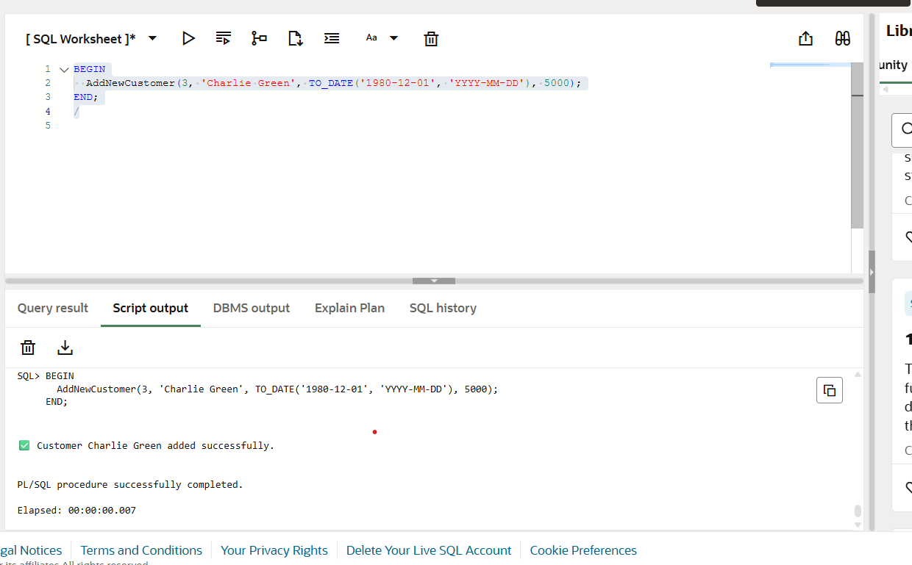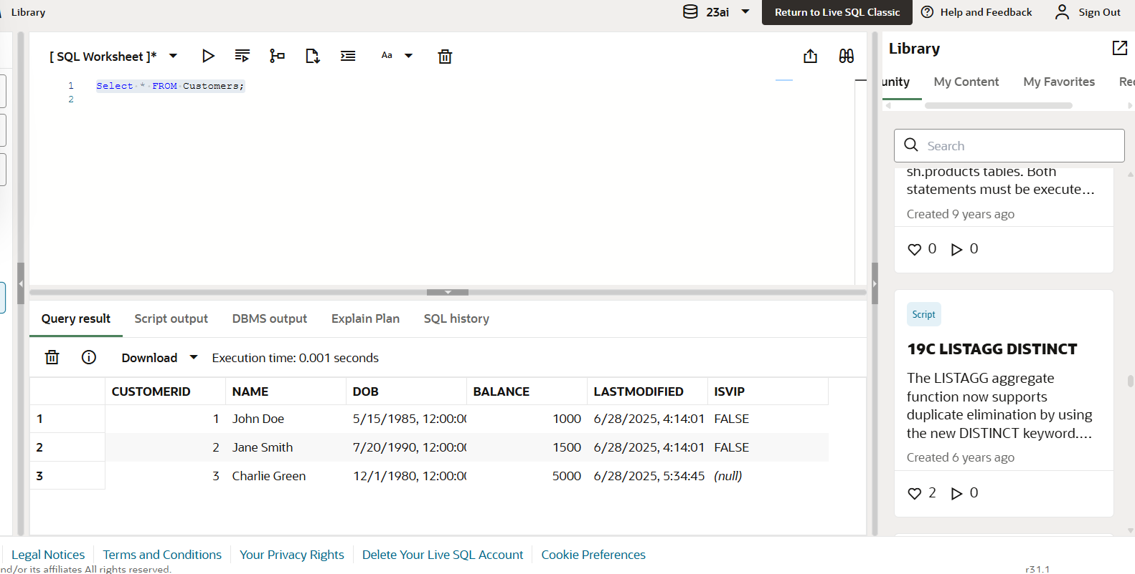

**Question 3:**

**Scenario 1:**

CREATE OR REPLACE PROCEDURE ProcessMonthlyInterest IS

BEGIN

FOR acc IN (

SELECT AccountID, Balance

FROM Accounts

WHERE AccountType = 'Savings'

) LOOP

UPDATE Accounts

SET Balance = Balance + (acc.Balance * 0.01),

LastModified = SYSDATE

WHERE AccountID = acc.AccountID;

DBMS_OUTPUT.PUT_LINE('✅ Interest added to Account ID ' || acc.AccountID);

END LOOP;

END;

/

**Test Query:**

BEGIN

ProcessMonthlyInterest;

END;

/

SELECT * FROM Customers;

**Outputs:**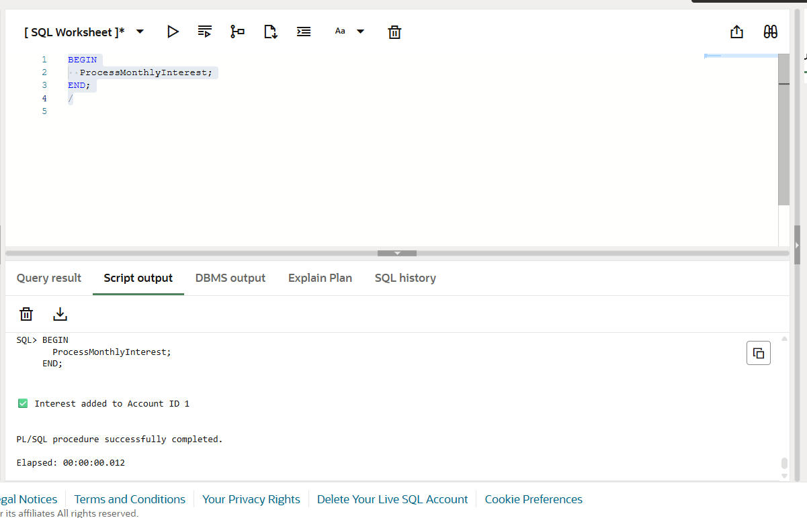

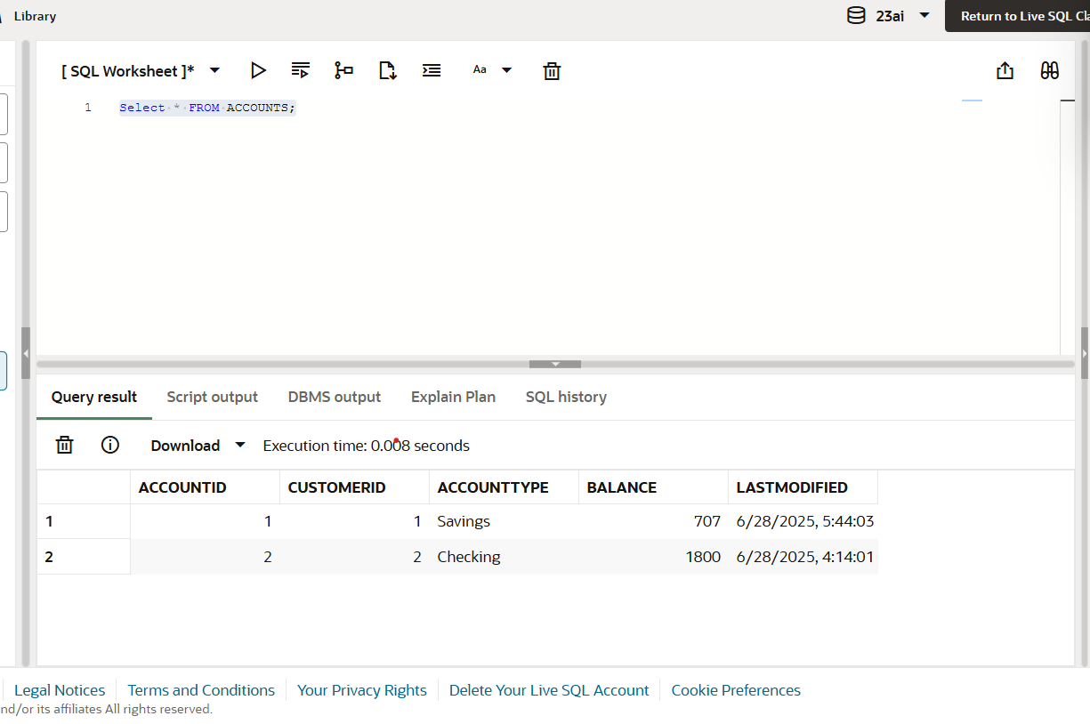

**Scenario 2:**

CREATE OR REPLACE PROCEDURE UpdateEmployeeBonus (

dept_name IN VARCHAR2,

bonus_percent IN NUMBER

) IS

BEGIN

UPDATE Employees

SET Salary = Salary + (Salary * bonus_percent / 100)

WHERE Department = dept_name;

DBMS_OUTPUT.PUT_LINE('✅ Bonus of ' || bonus_percent || '% applied to department ' || dept_name);

EXCEPTION

WHEN OTHERS THEN

DBMS_OUTPUT.PUT_LINE('❌ Error: ' || SQLERRM);

END;

/

**Test Query:**

BEGIN

UpdateEmployeeBonus('HR', 5);

END;

/

SELECT * FROM Employees;

**Outputs:**

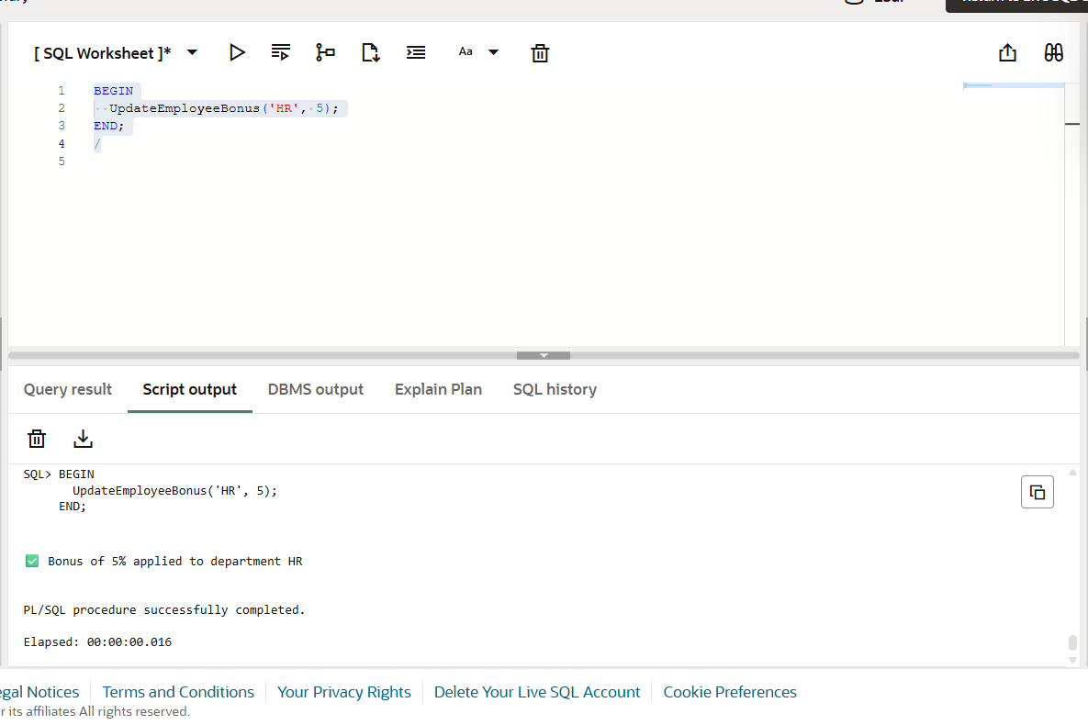

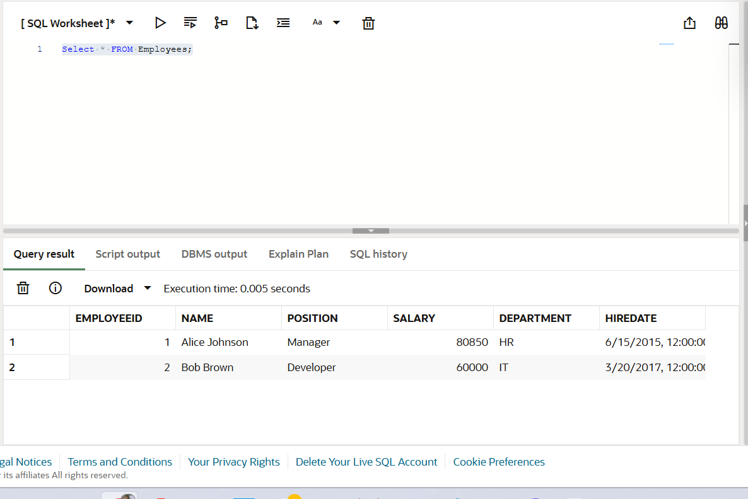

**Scenario 3:**

CREATE OR REPLACE PROCEDURE TransferFunds (

from_account IN NUMBER,

to_account IN NUMBER,

amount IN NUMBER

) IS

from_balance NUMBER;

BEGIN

-- Check available balance

SELECT Balance INTO from_balance FROM Accounts WHERE AccountID = from_account;

IF from_balance < amount THEN

DBMS_OUTPUT.PUT_LINE('❌ Transfer failed: Insufficient funds in Account ID ' || from_account);

RETURN;

END IF;

-- Deduct from sender

UPDATE Accounts

SET Balance = Balance - amount,

LastModified = SYSDATE

WHERE AccountID = from_account;

-- Credit to receiver

UPDATE Accounts

SET Balance = Balance + amount,

LastModified = SYSDATE

WHERE AccountID = to_account;

DBMS_OUTPUT.PUT_LINE('✅ Transferred $' || amount || ' from Account ID ' || from_account || ' to Account ID ' || to_account);

EXCEPTION

WHEN NO_DATA_FOUND THEN

DBMS_OUTPUT.PUT_LINE('❌ Error: One or both account IDs not found.');

WHEN OTHERS THEN

DBMS_OUTPUT.PUT_LINE('❌ Error: ' || SQLERRM);

END;

/

**Test Query:**

BEGIN

TransferFunds(1, 2, 200);

END;

/

Select * FROM Accounts;

**Outputs:**

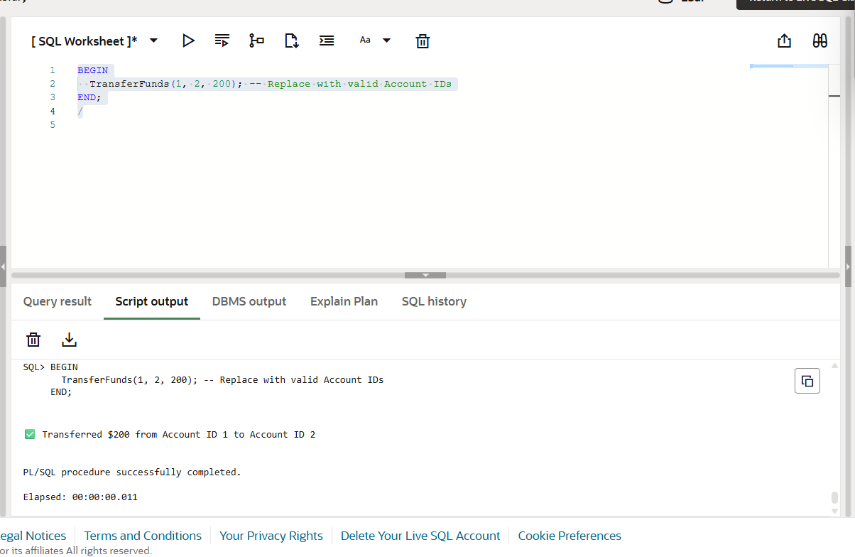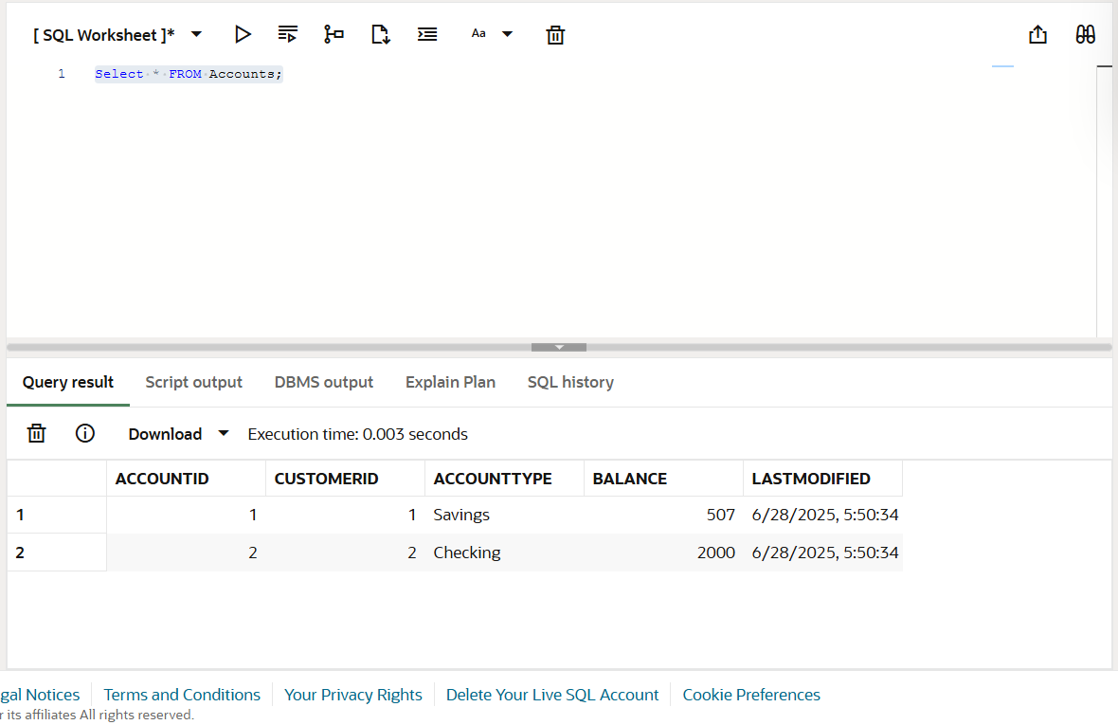

**Question 4:**

**Scenario 1:**

CREATE OR REPLACE FUNCTION CalculateAge (

  dob IN DATE

) RETURN NUMBER IS

  age NUMBER;

BEGIN

  age := FLOOR(MONTHS_BETWEEN(SYSDATE, dob) / 12);

  RETURN age;

END;

/

**Test Query:**

SELECT Name, DOB, CalculateAge(DOB) AS Age

FROM Customers;

**Output**

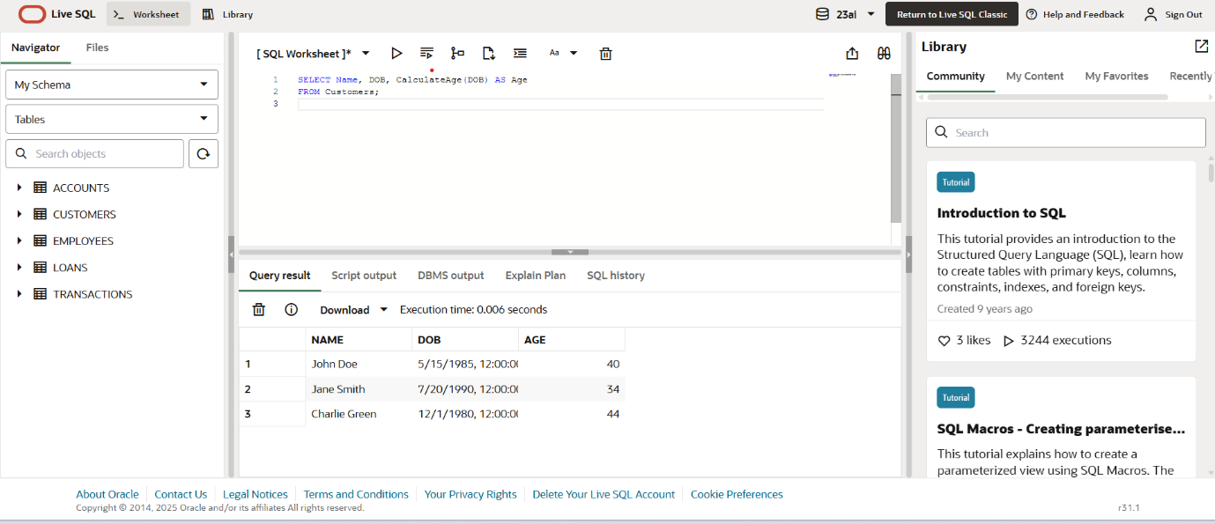

**Scenario 2:**

CREATE OR REPLACE FUNCTION CalculateMonthlyInstallment (

  loan_amount IN NUMBER,

  annual_interest_rate IN NUMBER,

  years IN NUMBER

) RETURN NUMBER IS

  r NUMBER; -- monthly interest rate

  n NUMBER; -- total months

  emi NUMBER;

BEGIN

  r := annual_interest_rate / 12 / 100;

  n := years * 12;

  IF r = 0 THEN

    emi := loan_amount / n;

  ELSE

    emi := loan_amount * r * POWER(1 + r, n) / (POWER(1 + r, n) - 1);

  END IF;

  RETURN ROUND(emi, 2);

END;

/

**Test Query:**

Formula Used : P * R * (1 + R)^N / ((1 + R)^N - 1) where :

* P = Loan Amount
* R = Monthly interest rate (annual rate / 12 / 100)
* N = Total number of monthly payments (years × 12)

Code:

SELECT CalculateMonthlyInstallment(10000, 6, 2) AS EMI FROM dual;

**Output:**

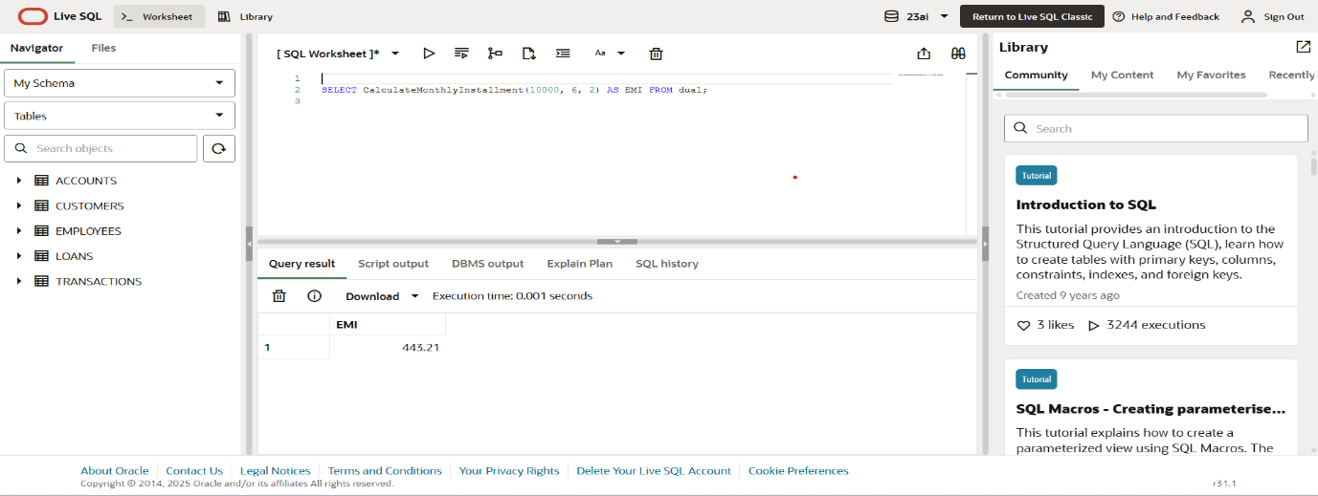

**Scenario 3:**

CREATE OR REPLACE FUNCTION HasSufficientBalance (

account_id IN NUMBER,

amount IN NUMBER

) RETURN NUMBER IS

bal NUMBER;

BEGIN

SELECT Balance INTO bal FROM Accounts WHERE AccountID = account_id;

IF bal >= amount THEN

RETURN 1; -- TRUE

ELSE

RETURN 0; -- FALSE

END IF;

EXCEPTION

WHEN NO_DATA_FOUND THEN

RETURN 0;

WHEN OTHERS THEN

RETURN 0;

END;

/

**Test Query:**

SELECT AccountID, HasSufficientBalance(AccountID, 500) AS CanPay

FROM Accounts;

**Outputs:**

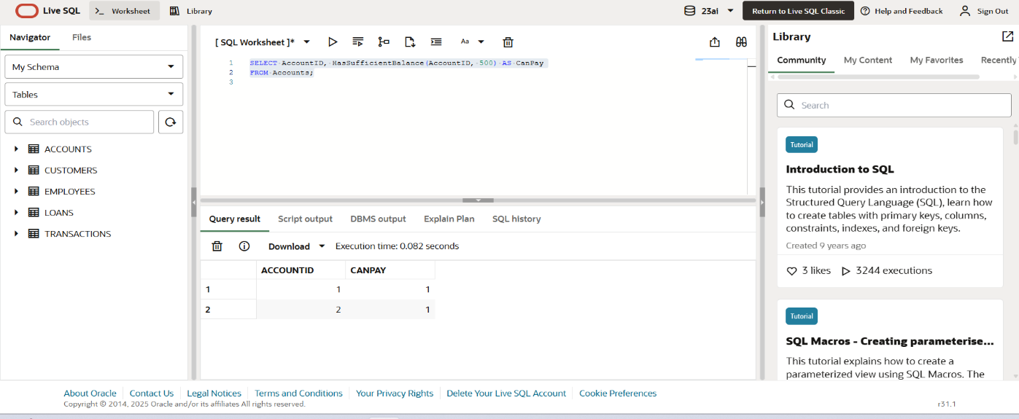

**Question 5:**

**Scenario 1:**

CREATE OR REPLACE TRIGGER UpdateCustomerLastModified

BEFORE UPDATE ON Customers

FOR EACH ROW

BEGIN

:NEW.LastModified := SYSDATE;

END;

/

**Test Query:**

UPDATE Customers

SET Name = 'Updated John'

WHERE CustomerID = 1;

//for checking if LastModified is Updated or not

SELECT CustomerID, Name, LastModified FROM Customers WHERE CustomerID = 1;

**Output**

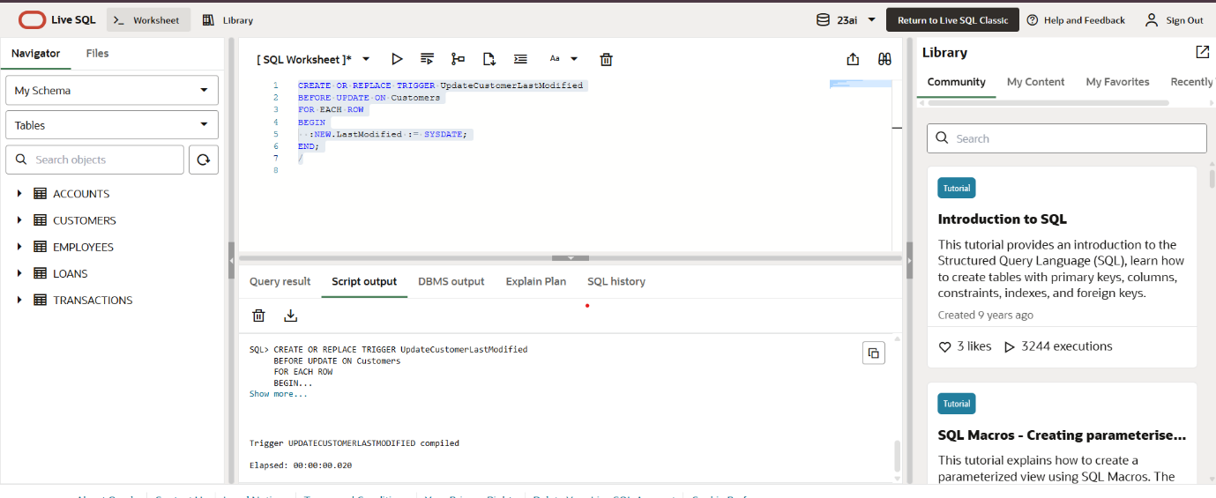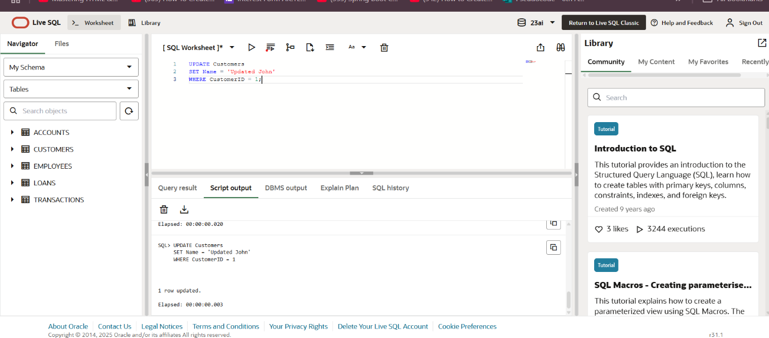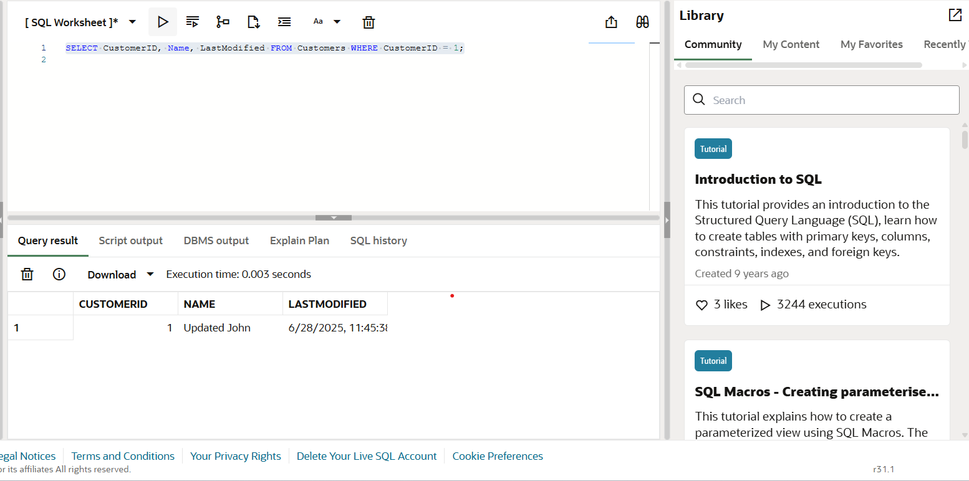

**Scenario 2:**

*Creating Audit Table*

CREATE TABLE AuditLog (

LogID NUMBER GENERATED ALWAYS AS IDENTITY PRIMARY KEY,

TransactionID NUMBER,

AccountID NUMBER,

Amount NUMBER,

TransactionType VARCHAR2(10),

LoggedAt DATE

);

*Trigger LogTransaction*

CREATE OR REPLACE TRIGGER LogTransaction

AFTER INSERT ON Transactions

FOR EACH ROW

BEGIN

INSERT INTO AuditLog (TransactionID, AccountID, Amount, TransactionType, LoggedAt)

VALUES (:NEW.TransactionID, :NEW.AccountID, :NEW.Amount, :NEW.TransactionType, SYSDATE);

END;

/

**Test Query:**

*Inserting a new transaction*

INSERT INTO Transactions (TransactionID, AccountID, TransactionDate, Amount, TransactionType)

VALUES (100, 1, SYSDATE, 300, 'Deposit');

*Checking the audit log*

SELECT * FROM AuditLog WHERE TransactionID = 100;

**Outputs:**

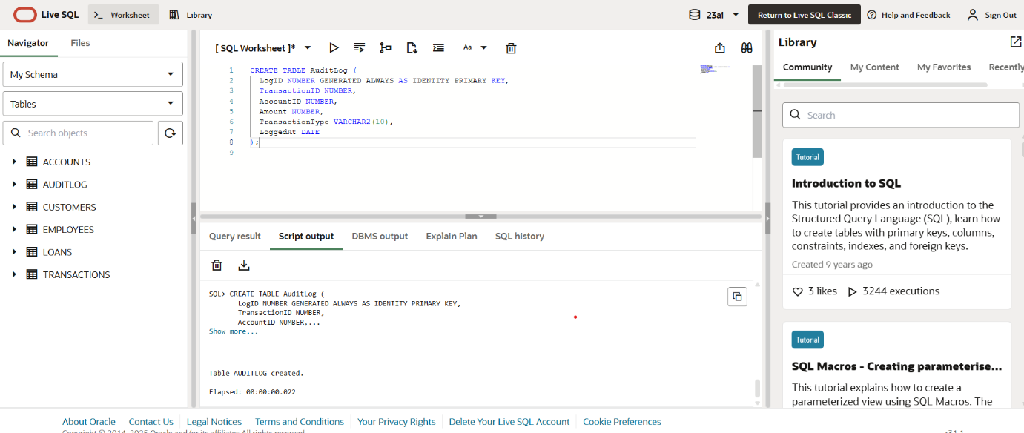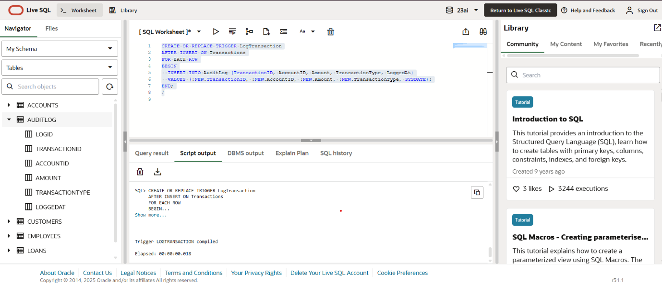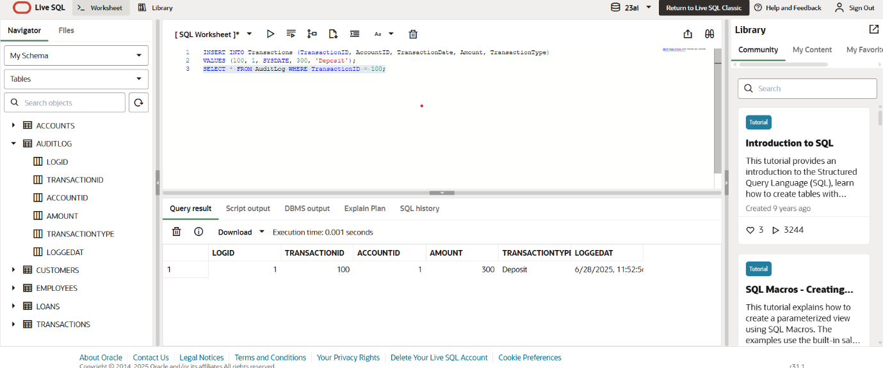

**Scenario 3:**

CREATE OR REPLACE TRIGGER CheckTransactionRules

BEFORE INSERT ON Transactions

FOR EACH ROW

DECLARE

acc_balance NUMBER;

BEGIN

-- Get account balance

SELECT Balance INTO acc_balance FROM Accounts WHERE AccountID = :NEW.AccountID;

-- Rule: Deposit must be positive

IF :NEW.TransactionType = 'Deposit' AND :NEW.Amount <= 0 THEN

RAISE_APPLICATION_ERROR(-20001, '❌ Deposit amount must be positive.');

END IF;

-- Rule: Withdrawal must not exceed balance

IF :NEW.TransactionType = 'Withdrawal' AND :NEW.Amount > acc_balance THEN

RAISE_APPLICATION_ERROR(-20002, '❌ Withdrawal exceeds account balance.');

END IF;

END;

/

**Test Queries:**

*Valid Insert:*

INSERT INTO Transactions (TransactionID, AccountID, TransactionDate, Amount, TransactionType)

VALUES (101, 1, SYSDATE, 100, 'Withdrawal');

*Invalid Insert – Deposit <= 0*

INSERT INTO Transactions (TransactionID, AccountID, TransactionDate, Amount, TransactionType)

VALUES (102, 1, SYSDATE, 0, 'Deposit');

*Invalid Insert – Withdrawal > Balance*

INSERT INTO Transactions (TransactionID, AccountID, TransactionDate, Amount, TransactionType)

VALUES (103, 1, SYSDATE, 999999, 'Withdrawal');

**Outputs:**

**Valid**

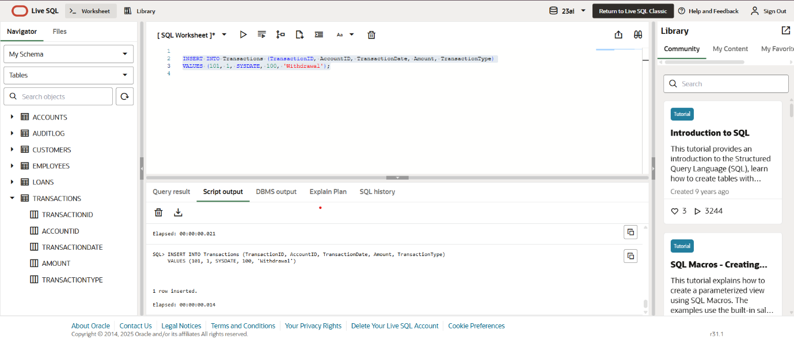

**Invalid**

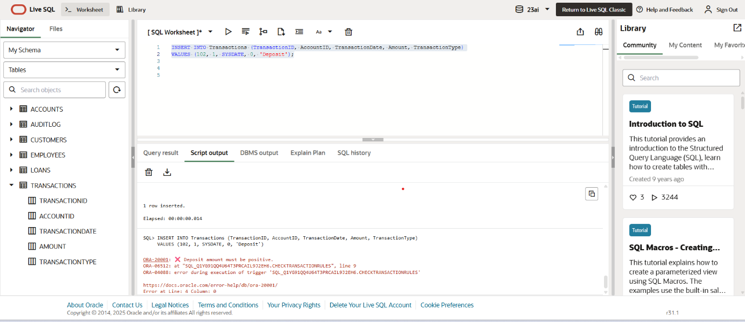

**Invalid**

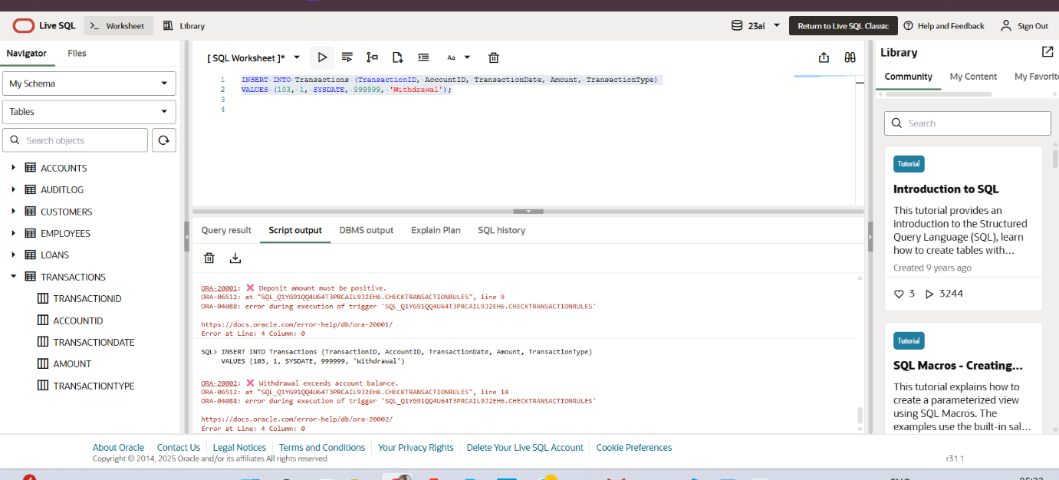

**Question 6:**

**Scenario 1:**

DECLARE

CURSOR cust_cursor IS

SELECT CustomerID, Name FROM Customers;

CURSOR txn_cursor (p_cust_id NUMBER) IS

SELECT t.TransactionDate, t.Amount, t.TransactionType

FROM Transactions t

JOIN Accounts a ON t.AccountID = a.AccountID

WHERE a.CustomerID = p_cust_id

AND TRUNC(t.TransactionDate, 'MM') = TRUNC(SYSDATE, 'MM');

v_cust_id Customers.CustomerID%TYPE;

v_name Customers.Name%TYPE;

v_date Transactions.TransactionDate%TYPE;

v_amount Transactions.Amount%TYPE;

v_type Transactions.TransactionType%TYPE;

BEGIN

FOR cust_rec IN cust_cursor LOOP

DBMS_OUTPUT.PUT_LINE('📄 Statement for: ' || cust_rec.Name);

OPEN txn_cursor(cust_rec.CustomerID);

LOOP

FETCH txn_cursor INTO v_date, v_amount, v_type;

EXIT WHEN txn_cursor%NOTFOUND;

DBMS_OUTPUT.PUT_LINE(' → ' || TO_CHAR(v_date, 'DD-Mon') || ' - ' || v_type || ': $' || v_amount);

END LOOP;

CLOSE txn_cursor;

DBMS_OUTPUT.PUT_LINE('----------------------------------');

END LOOP;

END;

/

**Outputs**

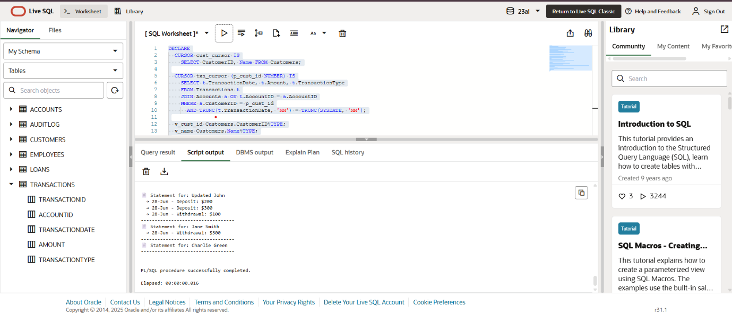

**Scenario 2:**

DECLARE

CURSOR account_cursor IS

SELECT AccountID, Balance FROM Accounts;

v_id Accounts.AccountID%TYPE;

v_bal Accounts.Balance%TYPE;

annual_fee CONSTANT NUMBER := 50;

BEGIN

FOR acc_rec IN account_cursor LOOP

IF acc_rec.Balance >= annual_fee THEN

UPDATE Accounts

SET Balance = Balance - annual_fee,

LastModified = SYSDATE

WHERE AccountID = acc_rec.AccountID;

DBMS_OUTPUT.PUT_LINE(' Annual fee deducted from Account ID: ' || acc_rec.AccountID);

ELSE

DBMS_OUTPUT.PUT_LINE(' Skipped Account ID ' || acc_rec.AccountID || ': Insufficient funds.');

END IF;

END LOOP;

END;

/

**Test Query:**

SELECT AccountID, Balance FROM Accounts;

**Outputs**

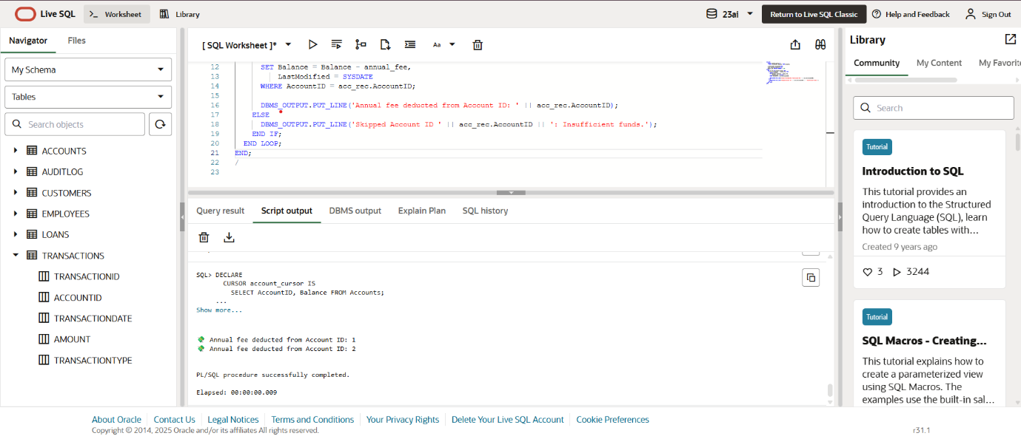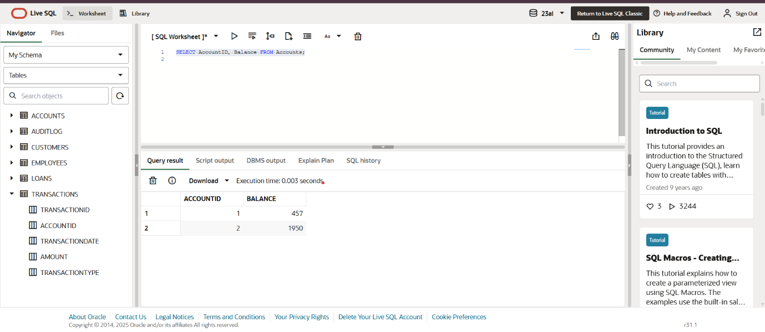

**Scenario 3:**

DECLARE

CURSOR loan_cursor IS

SELECT LoanID, LoanAmount, InterestRate FROM Loans;

v_id Loans.LoanID%TYPE;

v_amt Loans.LoanAmount%TYPE;

v_rate Loans.InterestRate%TYPE;

new_rate NUMBER;

BEGIN

FOR loan_rec IN loan_cursor LOOP

IF loan_rec.LoanAmount >= 10000 THEN

new_rate := loan_rec.InterestRate + 1.5;

ELSE

new_rate := loan_rec.InterestRate + 1.0;

END IF;

UPDATE Loans

SET InterestRate = new_rate

WHERE LoanID = loan_rec.LoanID;

DBMS_OUTPUT.PUT_LINE('📈 Loan ID ' || loan_rec.LoanID || ' interest updated to ' || new_rate || '%');

END LOOP;

END;

/

**Test Query:**

SELECT LoanID, LoanAmount, InterestRate FROM Loans;

**Outputs**

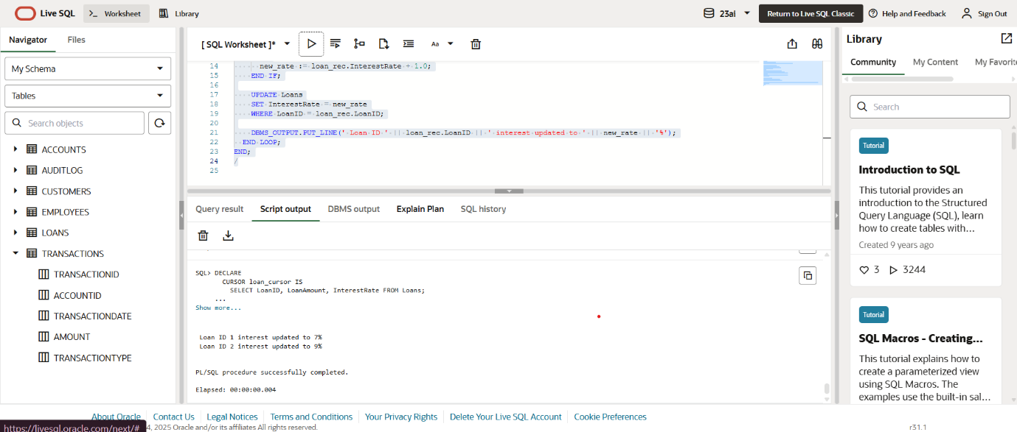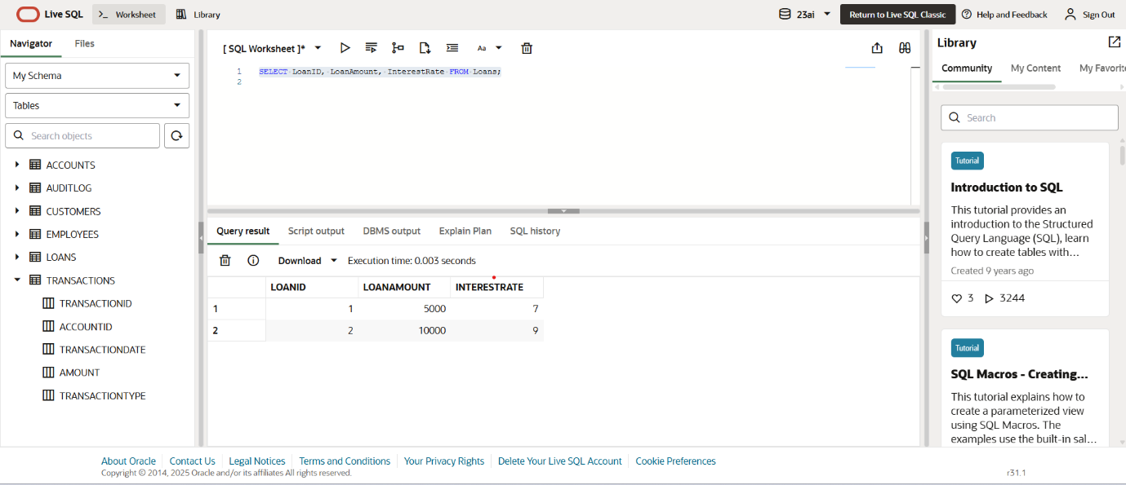

**Question 7:**

**Scenario 1:**

*Package Specification*

CREATE OR REPLACE PACKAGE CustomerManagement AS

PROCEDURE AddCustomer(p_id NUMBER, p_name VARCHAR2, p_dob DATE, p_balance NUMBER);

PROCEDURE UpdateCustomerDetails(p_id NUMBER, p_name VARCHAR2, p_dob DATE);

FUNCTION GetCustomerBalance(p_id NUMBER) RETURN NUMBER;

END CustomerManagement;

/

*Package Body*

CREATE OR REPLACE PACKAGE BODY CustomerManagement AS

PROCEDURE AddCustomer(p_id NUMBER, p_name VARCHAR2, p_dob DATE, p_balance NUMBER) IS

BEGIN

INSERT INTO Customers (CustomerID, Name, DOB, Balance, LastModified)

VALUES (p_id, p_name, p_dob, p_balance, SYSDATE);

END;

PROCEDURE UpdateCustomerDetails(p_id NUMBER, p_name VARCHAR2, p_dob DATE) IS

BEGIN

UPDATE Customers

SET Name = p_name,

DOB = p_dob,

LastModified = SYSDATE

WHERE CustomerID = p_id;

END;

FUNCTION GetCustomerBalance(p_id NUMBER) RETURN NUMBER IS

bal NUMBER;

BEGIN

SELECT Balance INTO bal FROM Customers WHERE CustomerID = p_id;

RETURN bal;

END;

END CustomerManagement;

/

**Test Query:**

BEGIN

CustomerManagement.AddCustomer(10, 'Charlie Blue', TO_DATE('1980-08-20', 'YYYY-MM-DD'), 5000);

CustomerManagement.UpdateCustomerDetails(10, 'Charlie Green', TO_DATE('1981-01-01', 'YYYY-MM-DD'));

DBMS_OUTPUT.PUT_LINE('Balance: ' || CustomerManagement.GetCustomerBalance(10));

END;

/

**Outputs:**

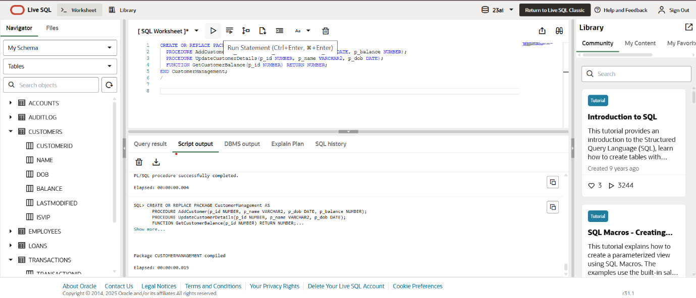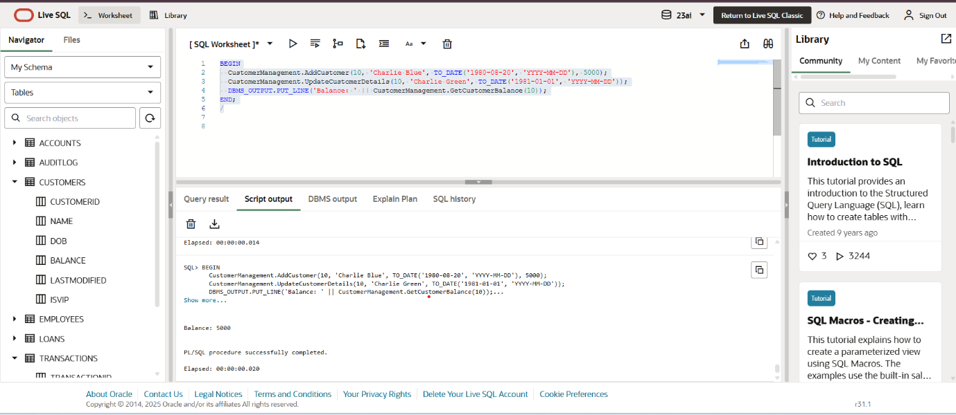

**Scenario 2:**

*Hiring*

DECLARE

v_name HR.EMPLOYEES.FIRST_NAME%TYPE;

v_job HR.EMPLOYEES.JOB_ID%TYPE;

v_salary HR.EMPLOYEES.SALARY%TYPE;

v_dept HR.EMPLOYEES.DEPARTMENT_ID%TYPE;

v_hire HR.EMPLOYEES.HIRE_DATE%TYPE;

BEGIN

SELECT FIRST_NAME, JOB_ID, SALARY, DEPARTMENT_ID, HIRE_DATE

INTO v_name, v_job, v_salary, v_dept, v_hire

FROM HR.EMPLOYEES

WHERE EMPLOYEE_ID = 101;

DBMS_OUTPUT.PUT_LINE('Simulated Hire: ' || v_name || ' | Job: ' || v_job || ' | Dept: ' || v_dept || ' | Salary: ' || v_salary);

END;

/

*Update*

DECLARE

v_old_salary HR.EMPLOYEES.SALARY%TYPE;

v_new_salary NUMBER;

v_old_dept HR.EMPLOYEES.DEPARTMENT_ID%TYPE;

v_new_dept NUMBER := 90;

BEGIN

SELECT SALARY, DEPARTMENT_ID

INTO v_old_salary, v_old_dept

FROM HR.EMPLOYEES

WHERE EMPLOYEE_ID = 101;

v_new_salary := v_old_salary + 1000;

DBMS_OUTPUT.PUT_LINE('Simulated Update: New Salary = ' || v_new_salary || ', New Department = ' || v_new_dept);

END;

/

*Actual Annual Salary Calculation*

DECLARE

v_salary HR.EMPLOYEES.SALARY%TYPE; -- declares variable with correct type

v_annual NUMBER; -- declares another variable

BEGIN

SELECT SALARY INTO v_salary

FROM HR.EMPLOYEES

WHERE EMPLOYEE_ID = 101;

v_annual := v_salary * 12;

DBMS_OUTPUT.PUT_LINE('Annual Salary: ' || v_annual);

END;

/

**Outputs**

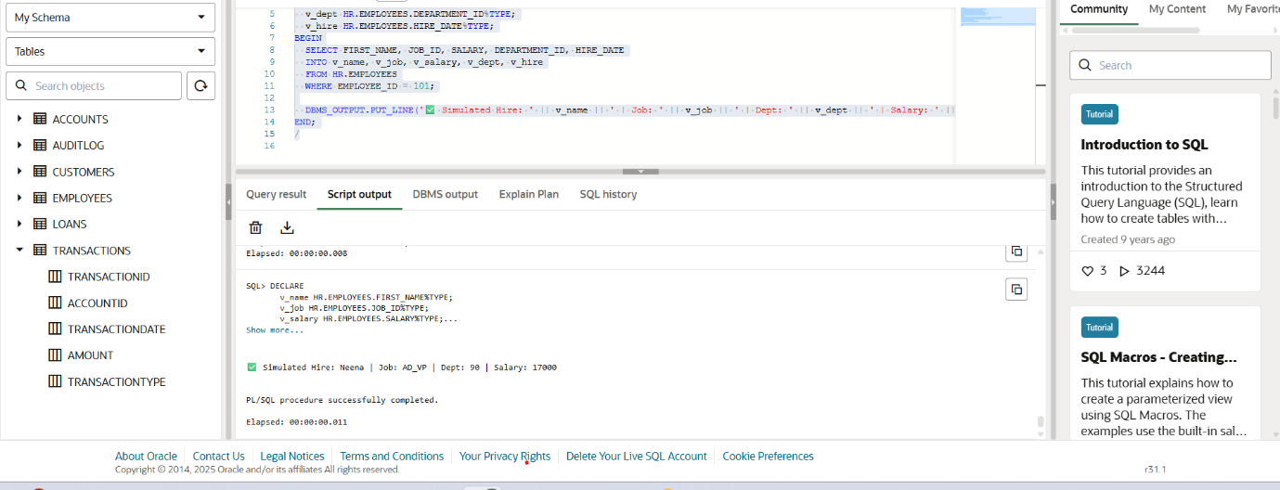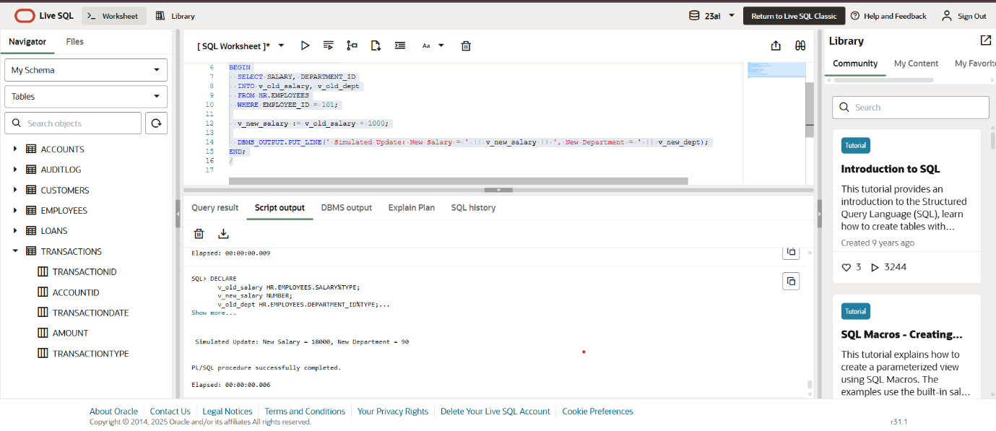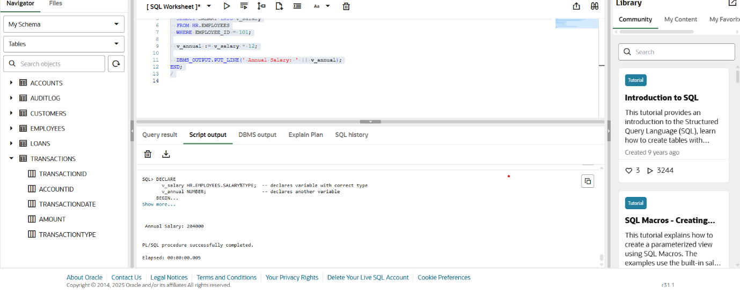

**Scenario 3:**

*Package Specification*

CREATE OR REPLACE PACKAGE AccountOperations AS

PROCEDURE OpenAccount(p_acc_id NUMBER, p_cust_id NUMBER, p_type VARCHAR2, p_balance NUMBER);

PROCEDURE CloseAccount(p_acc_id NUMBER);

FUNCTION GetTotalBalance(p_cust_id NUMBER) RETURN NUMBER;

END AccountOperations;

/

*Package Body*

CREATE OR REPLACE PACKAGE BODY AccountOperations AS

PROCEDURE OpenAccount(p_acc_id NUMBER, p_cust_id NUMBER, p_type VARCHAR2, p_balance NUMBER) IS

BEGIN

INSERT INTO Accounts (AccountID, CustomerID, AccountType, Balance, LastModified)

VALUES (p_acc_id, p_cust_id, p_type, p_balance, SYSDATE);

END;

PROCEDURE CloseAccount(p_acc_id NUMBER) IS

BEGIN

DELETE FROM Accounts WHERE AccountID = p_acc_id;

END;

FUNCTION GetTotalBalance(p_cust_id NUMBER) RETURN NUMBER IS

total NUMBER;

BEGIN

SELECT NVL(SUM(Balance), 0) INTO total FROM Accounts WHERE CustomerID = p_cust_id;

RETURN total;

END;

END AccountOperations;

/

**Test Query :**

BEGIN

AccountOperations.OpenAccount(20, 10, 'Savings', 800);

AccountOperations.OpenAccount(21, 10, 'Checking', 1200);

DBMS_OUTPUT.PUT_LINE('Total Balance for Customer 10: ' || AccountOperations.GetTotalBalance(10));

AccountOperations.CloseAccount(21);

END;

/

**Outputs:**

